Camblesforth Parish Council
Notice of Tender for Grass Cutting & Green Space Maintenance – 2022

The Parish Council wishes to invite tenders for its Grass Cutting and Green Space Tidy Contract, commencing April of this year.

Cost submissions should be in the form of a price per cut for the grass cutting, and for the tidying of the green spaces, and watering / deadheading of floral displays in the village. The schedule of cuts per year is: Areas 1 to 13 are cut 12 times (except – Area 2 which is to be strimmed 4 times a year) between the months of April and October and Area 14 and 15 are cut 6 times between these months.

A form is attached for convenience of submission (see page 3)

Sealed proposals outlining costs for the Parish Council to consider need to be submitted in written by email to Andrew Crabbe, Parish Clerk, no later than Friday 11th March, with a decision as to the successful contractor being determined at the March 2022 Parish Meeting. Submissions and enquiries need to be made to camblesforthclerk@sky.com and the plan of work for the year is as below:

Schedule of Grass cutting
 | Location | Details
Area 1 | Brigg Lane | Triangle of grass at exit onto Selby Road (A1041)
Area 2 | Brigg Lane | Grassed Verge (opposite) 64 Brigg Lane to the P3P junction (to be strimmed 4 times a year}
Area 3 | Brigg Lane | Triangle of grass with oak tree at end of Mill Lane
Area 4 | Brigg Lane | Grassed area at bus-stop / junction with Grange Road
Area 5 | Brigg Lane | Grass around bus stop (green shelter) corner of Croft Road
Area 6 | Croft Road | Grassed section near no.33 – (there is a grit bin on the section)
Area 7 | Croft Road | Grassed section on corner of Croft Road and Sandway Drive
Area 8 | Pinewood Drive | Grassed section on corner of Pinewood Drive and Sandway Drive
Area 9 | Pinewood Drive | Grassed verge front and side of houses where Pinewood Dr merges into Grange Rd
Area 10 | Mill Lane | Grassed verge near primary school
Area 11 | Brigg Lane | Grassed areas within playing field
Area 12 | Brigg Lane | Grassed areas within Memorial Garden (opposite the Church Hall)
Area 13 | Brigg Lane | Grassed areas within Millennium Garden (at junction of Beech Tree Lane)
Area 14 | Pinewood Drive | Grassed pathways in Allotments
Area 15 | A1041 | Area previously cut by NYCC – both sides of road from roundabout with A1041 to end of houses on left of road towards Selby (*see map below)

Village Gardens and Floral Displays
Alongside the above grass-cutting schedule, the contract also includes:
- keeping the three park areas (Memorial Garden, Main Park, and Millennium Garden) clear of litter by means of a monthly clean-up.
- watering and deadheading of (streetlight) hanging flower baskets and ground planters when required – April to September
Please quote separately from the grass-cutting for the above duties.

The successful contractor will be required to undertake other gardening responsibilities (ie maintenance of the bushes in the Memorial Garden, Brigg Lane Park and Millennium Garden) on an ad-hoc basis which will be decided outside of the main contract and subject to the circumstances of the requirement at the time

Map showing area of highways cut – from Carlton Roundabout to the Black Dog pub

Grass verges on either side of the highway

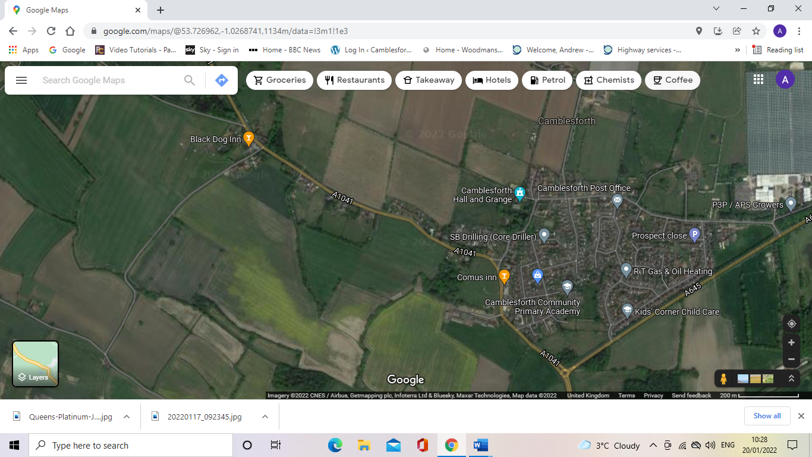

Camblesforth Parish Council
Submission Form for Grass Cutting and Green Space Maintenance (2022)

________________________________________________________________________________________________

Name of Contractor/Business ……………………………………………………………………………….

Year Business Commenced ……………………………………………………………………………………

_________________________________________________________________________________________________

Proposed Charges

- Price Per Cut = ……………….. per cut: Total per annum ………………….
(Areas 1 to 13 – excluding Area 2 - are cut 12 times between the months of April and October and Areas 14 & 15 are cut 6 times between these months). Area 2 is strimmed 4 times a year.

- Monthly Charge for litter removal on three green spaces in village = …………….

3) Monthly charges for watering and deadheading of floral displays(hanging baskets and two planters) in the village = …………..

- Statement in support of proposal (please use this section to explain experience of similar work or anything you wish the Parish Council to take into consideration

……………………………………………………………………………………………………………………………

………………………………………………………………………………………………………………………………

………………………………………………………………………………………………………………………………

………………………………………………………………………………………………………………………………

………………………………………………………………………………………………………………………………

………………………………………………………………………………………………………………………………

Important Note: The successful contractor will be required to provide original copies of insurance and certificates permitting use of mechanised machinery, prior to the approval of any contract

Signed and dated ………………………………………………………………………………………

_________________________________________________________________________________________________

Please return this form either by email to camblesforthclerk@sky.com or by post to Andrew Crabbe, 27 Willowgarth, Eastrington Village, nr Howden. DN14 7QP

