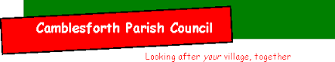
Parish Chairman: Neal Yates
Parish Deputy Chair: Stephanie Coleman
___________________________________________________________________________

The August 2021 Meeting of the Parish Council was cancelled due to illness

Signed as a true record……… Neal Yates…………….. Date…… September 2021
Neal Yates – Parish Chairman

