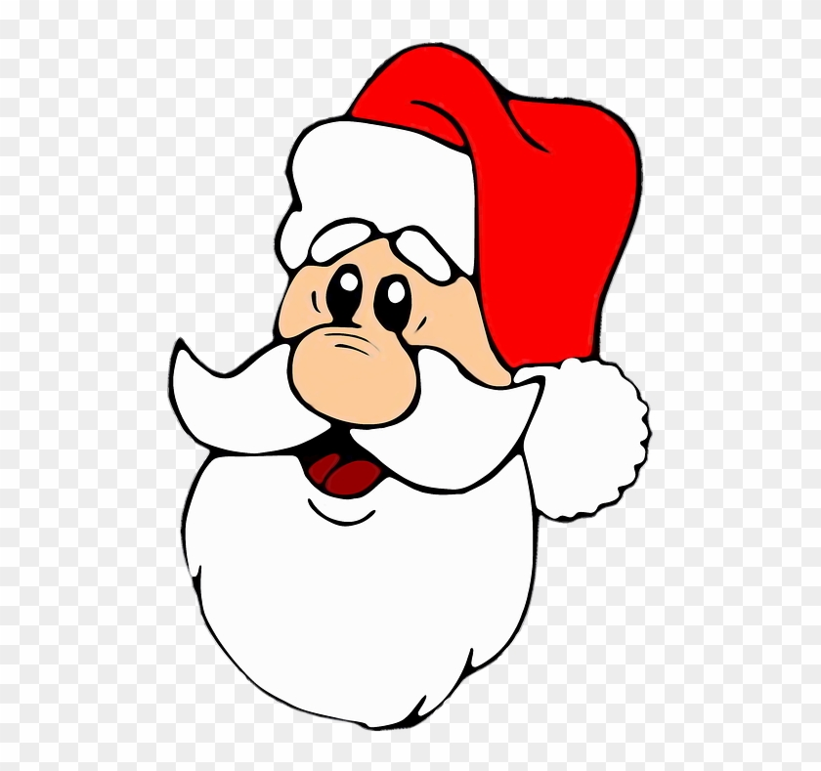

A Message from Father Christmas to all the boys and girls in Camblesforth
I am so sorry that I won’t be able to make my usual visit to the village this year, (don’t worry I will still be coming down your chimney on Christmas Eve) but I would like to still ensure all the boys and girls who have been good this year receive a little present especially from me
If your grown-ups feel you have been good, ask them to read my message to them below
Lots of Love
Father Christmas and Rudolf
Bit for the Grown-ups
My helpers will drop off a small present addressed to your child on the weekend of 19th December – please let us have your child’s name and the address where you want us to drop the present off.
Name of Child……………………………………………………………………………………………………………………….
Address ……………………………………………………………………………………………………………………………….……………………….
Please return this form to camblesforthclerk@sky.com or drop off at 4 Barns Elm, no later than 11th December.

